CS5560 Knowledge Discovery and Management

Problem Set (PS-2A)

June 12, 2017

Name: suggala prudhvi sai

Class ID: 26

1. Draw knowledge graphs (both Schema and Data graphs)

CHICAGO (AP) — Citing high fuel prices, United Airlines said Friday it has increased fares by $6 per round trip on flights to some cities also served by lower-cost carriers. American Airlines, a unit AMR, immediately matched the move, spokesman Tim Wagner said. United, a unit of UAL, said the increase took effect Thursday night and applies to most routes where it competes against discount carriers, such as Chicago to Dallas and Atlanta and Denver to San Francisco, Los Angeles and New York.

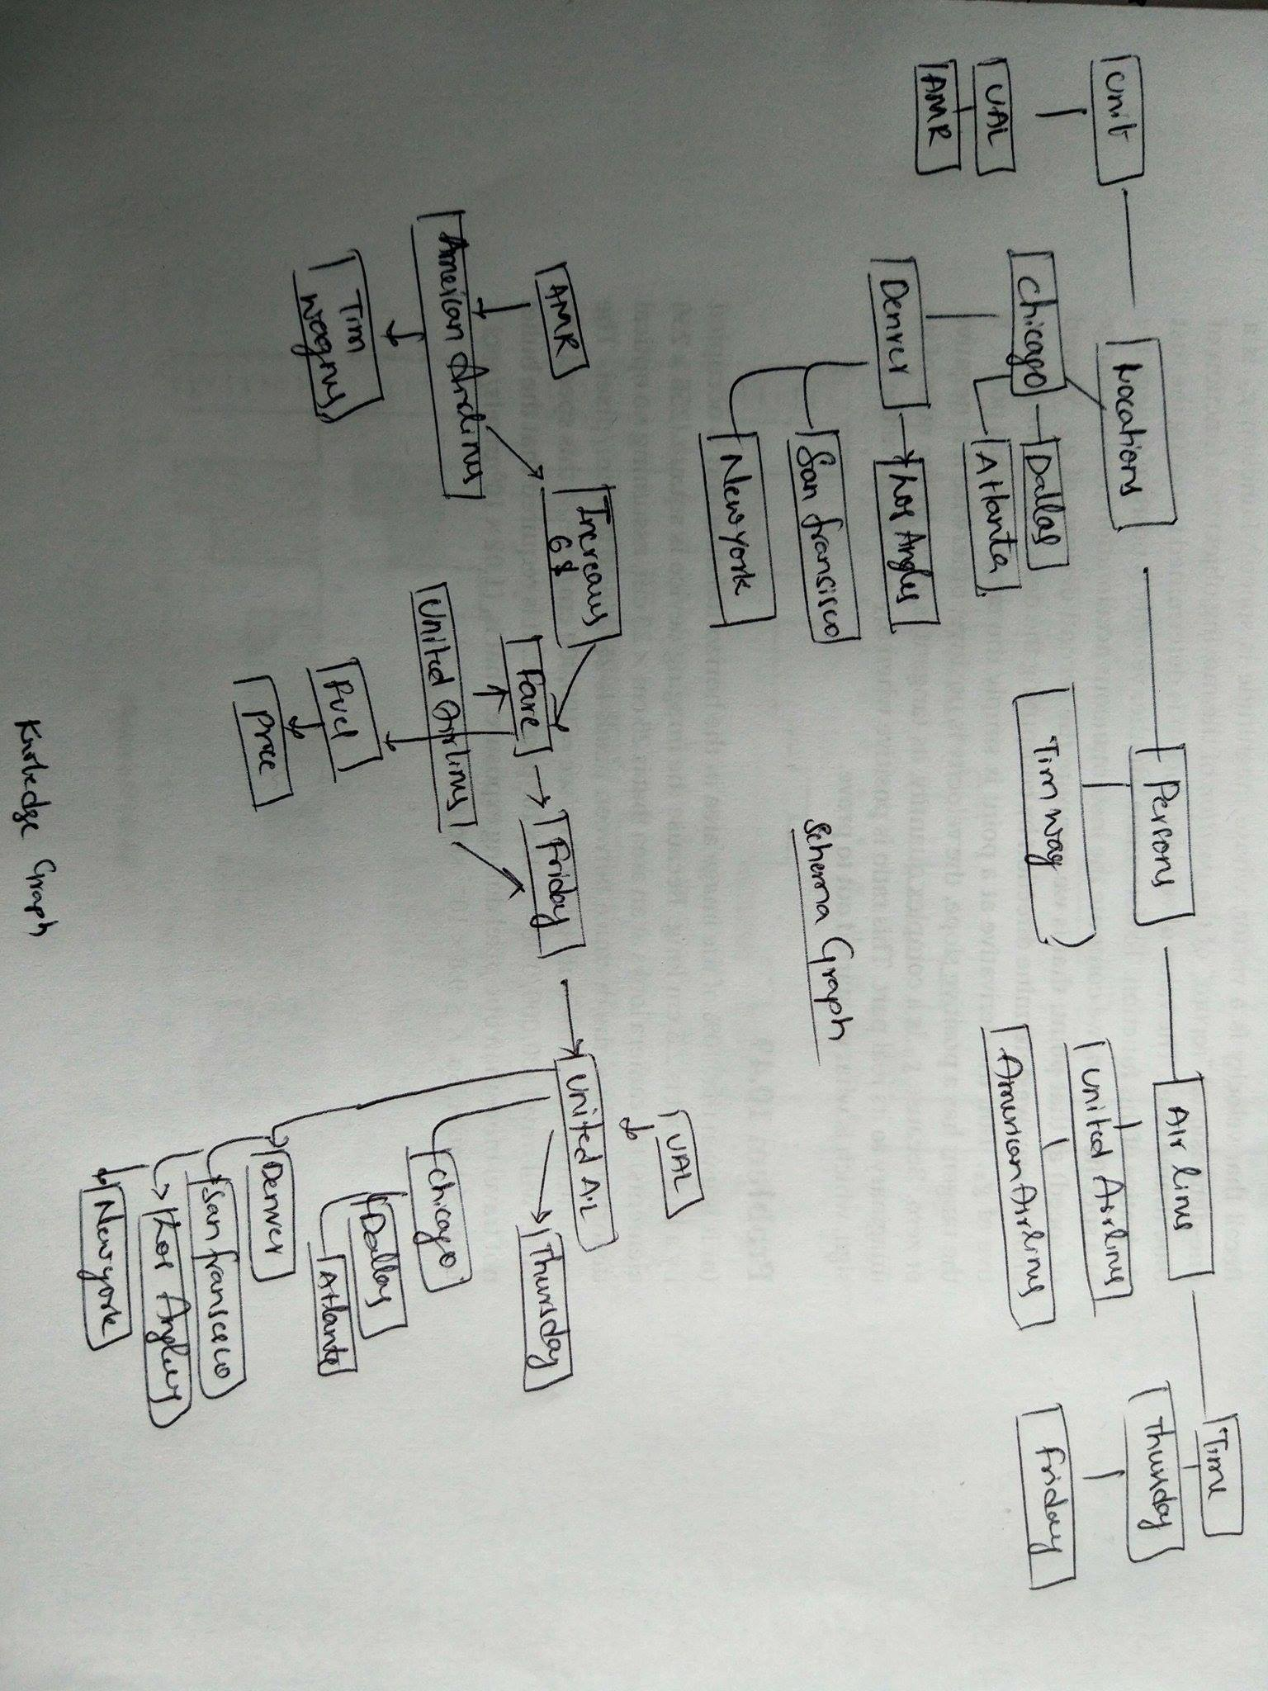

1. Design question answering for the given input text. Try to include at least one questions for the following question types.

* What
* Where
* When
* Who
* How
* How much
* Yes/No

o What airlines has increased the prices.

o Where the United Airlines announced the increased fares.

o When the united airlines did announced the increase in the fares.

o Who is the spokesperson of American airlines

o How many airlines has increased the prices.

o How much is the increase in the flight fares.

o Does American Airlines increased the fare.